**HALF ADDER:**

**EXP NO:21**

**AIM:**To design and implement the two-bit half-adder using the Logisim simulator.

**APPARATUS:** logicism

**PROCEDURE:**

1)Pick and place the necessary gates.  
2) Insert 2 inputs into the canvas.  
3) Connect the inputs to the XOR gate and AND gate.  
4) Insert 2 outputs into the canvas.  
5) Make the connections using the connecting wires.  
6) Verify the truth table.

**TRUTH TABLE:**

**FOR SUM:**

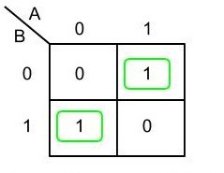

**S=A XOR B**

**FOR CARRY:**

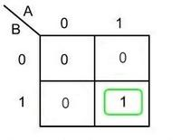

**C=A AND B**

**OUTPUT:**

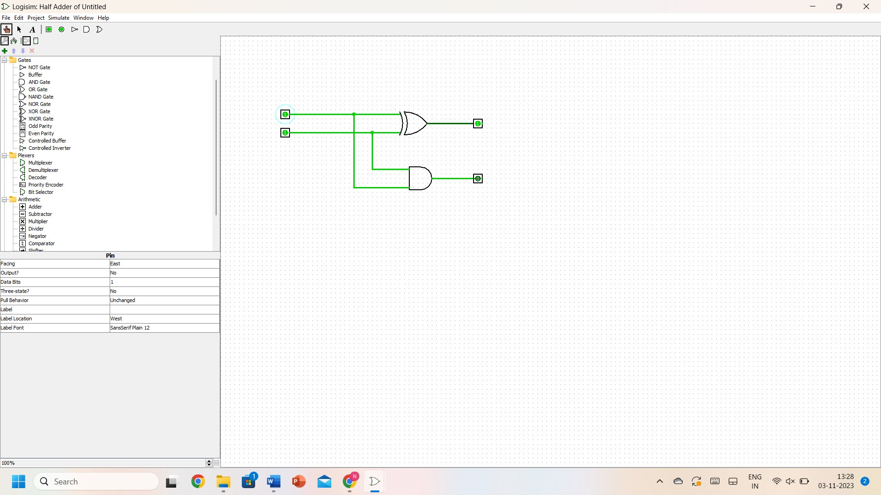

**RESULT:** Thus 2-bit half adder has been designed and implemented successfully using a Logisim simulator.